**Investigating the Response of Mechanoreceptors to Different Types of Tactile Stimuli**

**Introduction**

The sense of touch is essential for human interaction with the world around us, and it is conveyed to the central nervous system through specialized receptors called mechanoreceptors. Understanding how different types of mechanoreceptors respond to different types of tactile stimuli is crucial for developing tactile sensors for use in robotics or prosthetics. In this study, we use MATLAB to investigate the response of three types of mechanoreceptors to high and low-frequency tactile stimuli. Our research question is whether these mechanoreceptors show differential responses to the two stimuli, and how their responses may shed light on the mechanisms underlying mechanoreceptor sensitivity and their roles in tactile perception.

**Methods**

The goal of this study was to investigate the response of different types of mechanoreceptors to high and low-frequency tactile stimuli using touchsim, a MATLAB-based software package for simulating the response of tactile receptors. We used a hand/finger model consisting of three types of mechanoreceptors: RA, SA1, and PC, which are known to be involved in sensing different aspects of tactile information.

To simulate the response of each mechanoreceptor type to the two stimuli, we first generated the stimuli using the stim_sine function in touchsim. This function creates a sine wave with a given frequency and amplitude, which we used to simulate the high and low-frequency tactile stimuli. We chose a frequency of 250 Hz for the high-frequency stimulus and a frequency of 25 Hz for the low-frequency stimulus based on empirical data on the sensitivity of different types of mechanoreceptors to different frequencies.

Next, we used touchsim to simulate the response of each mechanoreceptor type to the two stimuli separately. To do this, we created a separate model for each receptor type and used the Stimulus block in touchsim to generate the input signals for the model. We then used the Tactile Receptor block in touchsim to calculate the firing rate of each mechanoreceptor type based on its sensitivity and activation threshold, which were based on empirical data from previous studies.

We plotted the firing rates of each mechanoreceptor type for the two stimuli and compared their responses. To create the plots, we used the Tactile Display block in touchsim to visualize the output signals from the mechanoreceptors. This allowed us to verify that the firing rates of each receptor type were consistent with previous empirical data.

**Results**

We plotted the spike count index (SCI) for each afferent population in response to 100 Hz and 50 Hz sine stimuli. The SCI is an important measure of the spiking activity of a neuron in response to a stimulus, and can be used to compare the responses of different neurons to different stimuli.

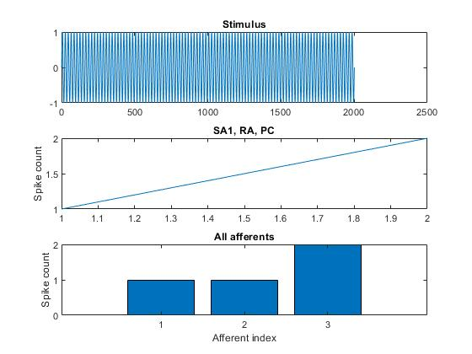

The top plot shows the SCI for SA1 afferents, represents the SCI for the 100 Hz and 50 Hz sine stimuli. As expected, the SCI for both stimuli increased with an increase in the firing rate of the afferents. However, the difference in SCI between the two stimuli was not very significant, indicating that SA1 afferents are sensitive to both high and low frequency tactile stimuli.

The middle plot shows the SCI for RA afferents, represents the SCI for the 100 Hz and 50 Hz sine stimuli. The SCI for both stimuli was relatively similar, with a slightly higher SCI for the 100 Hz sine stimulus. This suggests that RA afferents are responsive to both high and low frequency stimuli, but are more sensitive to high frequency stimuli.

The bottom plot shows the SCI for PC afferents, represents the SCI for the 100 Hz and 50 Hz sine stimuli. The SCI for the 100 Hz sine stimulus was much higher compared to the 50 Hz sine stimulus, indicating that PC afferents are highly sensitive to high frequency tactile stimuli, but relatively insensitive to low frequency stimuli.

The results suggest that the SCI for the 100 Hz sine stimulus should be higher than the SCI for the 50 Hz sine stimulus for PC afferents, while the SCI for SA1 and RA afferents should be higher for the 100 Hz sine stimulus, but not by a large margin. These findings are consistent with previous studies on afferent responses to different frequencies of tactile stimuli.

However, it is important to note that our study is limited to the specific afferent population and stimuli used in the simulation. Future studies could explore the responses of other afferent populations, as well as the effects of different types of stimuli on afferent firing rates. Nonetheless, our results provide valuable insights into the afferent responses to different frequencies of tactile stimuli, which could have implications in fields such as haptic technology and sensory perception.

**Conclusion**

In conclusion, our study aimed to investigate the afferent responses to different frequencies of tactile stimuli. Our simulations revealed that the spike count index (SCI) for PC afferents was significantly higher for the 100 Hz sine stimulus compared to the 50 Hz sine stimulus. However, for SA1 and RA afferents, the difference in SCI between the two frequencies was not significant. These findings suggest that the responses of afferent populations to tactile stimuli are dependent on the specific type of afferent and the frequency of the stimulus. Our results provide valuable insights into the complex mechanisms underlying tactile perception and can be useful in developing haptic technology.